**Retrieve Student Data from a Text File**

**GitHub Link: :** [https: //github.com/RBhuvaneswari01/mainprojects](https://github.com/pravallikaadineni/mainprojects.git)

**Step 1:** Creating a Simple text file externally using Notepad pre-populated with the Student data and naming it as “studentdata.txt”.

**Step 2**: Creating a Windows Console project in Visual Studio to display student data.

● Open Visual Studio.

● From the top menu select File->New->Project.

● In Create A New Project Screen, select Console app (.NET Core) from the list of available project types and click on Next.

● Enter Project Name mainproject1 as and click on Create.

**Step 3:**

Select the program.cs file on current tab and enter the code

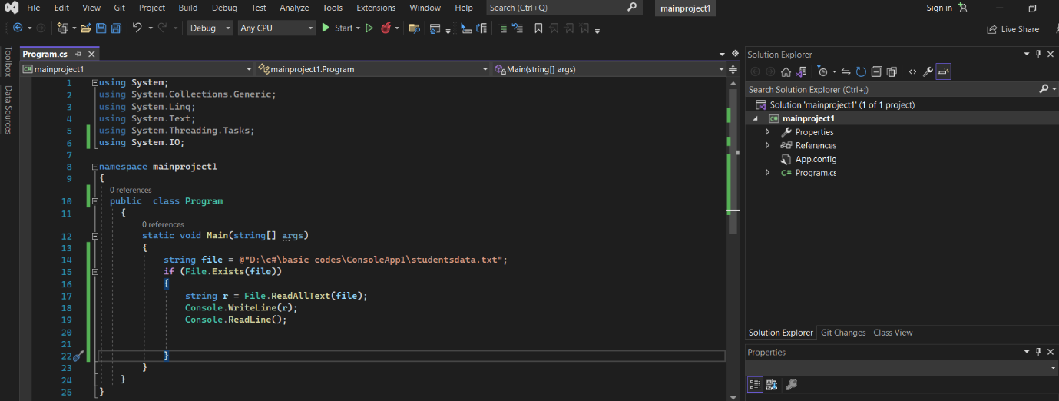

**Step 4:**Building the project

● From the top menu choose Build->Build Solution.

● If any compile errors are shown, fix them as required.

**Step 5:**Publishing and running the project

● From the top menu select Debug->Start Without Debugging.

● This will execute the program in a console window.

**Step 6:**Pushing the code to your GitHub repositories

Open your command prompt and navigate to the folder where you have created your files.

**cd <folder path>**

Initialize your repository using the following command:

**git init**

Add all the files to your git repository using the following command:

**git add.**

Commit the changes using the following command:

**git commit -m “upload”**

Push the files to the folder you created initially using the following command:

**git push -u origin main**